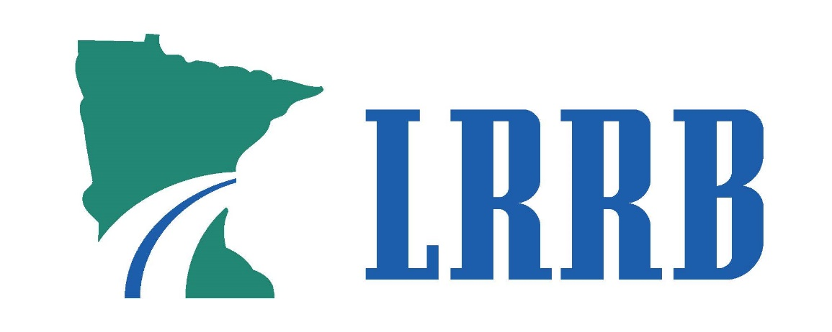

**Member Orientation Guide**

A guide for members of the Minnesota Local Road Research Board

Version 4. June 8, 2019

**For more information about LRRB, please contact:**

Director, Office of Research & Innovation

Minnesota Department of Transportation

MS 330, First Floor

395 John Ireland Blvd.  
St. Paul, MN 55155-1800  
(Phone) 651-366-3765  
research.dot@state.mn.us  
[mndot.gov/research](http://" \o "MDH website)

**Contents**

[List of Abbreviations 5](#_Toc11657648)

[Introduction 6](#_Toc11657649)

[Document Purpose 6](#_Toc11657650)

[LRRB Organization 6](#_Toc11657651)

[Research Implementation Committee 9](#_Toc11657652)

[The Outreach Subcommittee 10](#_Toc11657653)

[Office of Research & Innovation 11](#_Toc11657654)

[Center for Transportation Studies (CTS), University of Minnesota 12](#_Toc11657655)

[Research Project Development 13](#_Toc11657656)

[LRRB Research Lifecycle 13](#_Toc11657657)

[Needs Identification 15](#_Toc11657658)

[Proposals 17](#_Toc11657659)

[Research Project Selection 17](#_Toc11657660)

[Work Plans and Contracts 18](#_Toc11657661)

[Project Technical Advisory Panel 18](#_Toc11657662)

[Research Project Execution 18](#_Toc11657663)

[Reports and Deliverables 18](#_Toc11657664)

[Performance Assessment 18](#_Toc11657665)

[Implementation 19](#_Toc11657666)

[Research Project Implementation 20](#_Toc11657667)

[Implementation Project Selection Process 20](#_Toc11657668)

[Implementation Roles and Responsibilities 21](#_Toc11657669)

[Implementation Tools 22](#_Toc11657670)

[Implementation Partnerships 22](#_Toc11657671)

[Evaluation 23](#_Toc11657672)

[Research Resources 25](#_Toc11657673)

[Research Project Expertise 25](#_Toc11657674)

[Research Support 25](#_Toc11657675)

[Meetings, Workshops, and Reports 28](#_Toc11657676)

[LRRB Meetings 29](#_Toc11657677)

[RIC Meetings 30](#_Toc11657678)

[Annual “LRRB At-A-Glance” Reports 32](#_Toc11657679)

[LRRB Management and Administrative Activities 33](#_Toc11657680)

[Administrative Budget 33](#_Toc11657681)

[Funding Cycle 33](#_Toc11657682)

[LRRB Rollover Money 33](#_Toc11657683)

[Financial Services 34](#_Toc11657684)

[Appendix A. Affiliated Programs and Collaborating Research Organizations 35](#_Toc11657685)

[Appendix B. Knowledge Building Priorities: Update Process and Current Topics 37](#_Toc11657686)

[Appendix C. CTS Research Councils 40](#_Toc11657687)

[Appendix D. LRRB and RIC Annual Research Program Development Process 42](#_Toc11657688)

## List of Abbreviations

|  |  |
| --- | --- |
| ARTS | Automated Research Tracking System |
| CEAM | City Engineers Association of Minnesota |
| CTAP | Circuit Training and Assistance Program |
| CTS | Center for Transportation Studies |
| DOT | Department of Transportation |
| FHWA | Federal Highway Administration |
| ITS | Institute of Transportation Studies |
| LRRB | Local Road Research Board |
| LTAP | Local Technical Assistance Program |
| MCEA | Minnesota County Engineer Association |
| MnDOT | Minnesota Department of Transportation |
| MCAE | Multicultural Center for Academic Excellence |
| NRRA | National Road Research Alliance |
| OC | Outreach Committee |
| OPERA | Operational Research Assistance Program |
| PA | Project Advisor |
| PI | Principal Investigator |
| RFP | Request for Proposal |
| RIC | Research Implementation Committee |
| TAP | Technical Advisory Panel |
| TL | Technical Liaison |
| TRAP | Transportation Research Assistance Program (certified consultant list) |

## Introduction

The Minnesota Local Road Research Board (LRRB) has consistently served Minnesota transportation practitioners for decades. The LRRB was established in 1959, created and empowered by the state legislation to sponsor transportation research ([Minnesota Administrative Rule Chapter 8820, Part 3200](https://www.revisor.mn.gov/rules/8820.3200/)). LRRB has sponsored more than 200 research projects over the last 15 years, addressing the problems and challenges in providing a safe and efficient local transportation system across Minnesota. While the organization has evolved over that time, its fundamental mission remains evergreen: "to serve local road practitioners through the development of new initiatives, the acquisition, and application of new knowledge, and the exploration and implementation of new technologies.”

LRRB sponsors research that will ultimately improve the quality of the transportation system, particularly the projects that help improving “the design, construction, maintenance and environmental compatibility of the state-aid highways, streets, and appurtenances”.

### Document Purpose

This Member Orientation Guide (MOG) is a resource summarizing LRRB’s history, structure, and approach to operations. This Guide is written for new LRRB members, those who are new to LRRB, or those who would like to become familiar with it. It can also serve as a helpful resource for others who are currently involved with LRRB research efforts and would like to review or refresh their understanding. The Guide discusses the lifecycle and approach to research, implementation, and knowledge transfer, as well as project and program administration and management activities.

We welcome feedback on the content and usefulness of this document and encourage members to alert us to the need for updates or new information. Direct your feedback to the contact person listed on the inside front cover of this document.

### LRRB Organization

LRRB activities address the immediate and forward-looking transportation knowledge needs of Minnesota city and county agencies, local Minnesota Department of Transportation (MnDOT) staff, and streams of research identified by academics that are applicable to the local transportation system.

Since LRRB is a governance organization with the ability to sponsor research and convene stakeholders and not an executing agency, LRRB accomplishes its priorities by fostering and sponsoring collaborative research efforts among the Minnesota transportation community.

The Board’s organizational structure includes a mix of internal committees, bolstered by external partner relationships. The following chart presents the organization of the entities who contribute to supporting LRRB’s research efforts in Minnesota.

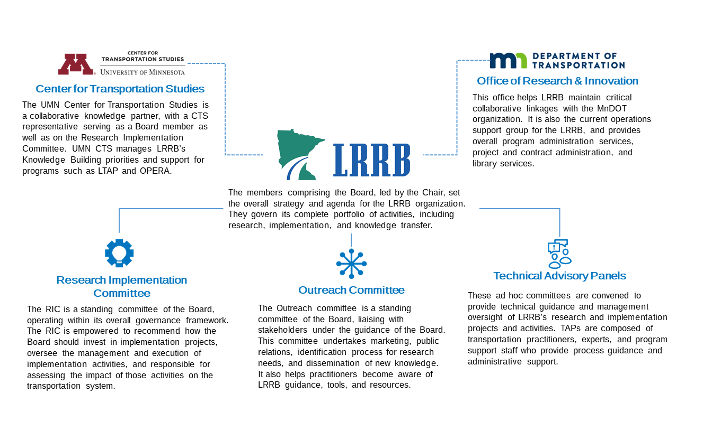

Figure 1 LRBB: Organization of Research Activities

#### *Membership*

LRRB is comprised of the following members to support research project development and implementation in Minnesota:

* Four county and two city engineers,
* MnDOT staff, including: a State Aid Engineer, a MnDOT Expert Office representative, and the Office of Research and Innovation Director, who is the ex-officio secretary,
* A representative from University of Minnesota Center for Transportation Studies.

LRRB membership is described in [Minnesota Administrative Rule 8820.3200](https://www.revisor.mn.gov/rules/8820.3200/). LRRB includes 10 members who nominate and elect a chair.

The State Aid Engineer selects new members through consultation with the Board. Once selected, the new members receive an appointment letter prepared by the State Aid Administrative Assistant and signed by the commissioner. Then the chair introduces new LRRB members at the beginning of their first board meeting participation. The MnDOT’s Office of Research & Innovation director updates the LRRB roster and post it on the LRRB website.

#### *Responsibilities of LRRB Members*

LRRB’s chair is responsible for assisting in the preparation of the board meeting agendas and leading the board meetings, organizing ad-hoc committees as necessary, and appointing committee members and chairs. In addition to these responsibilities, the chair or another designated LRRB member, represents the LRRB on research governance committees, such as those of the [National Road Research Alliance (NRRA)](http://www.dot.state.mn.us/mnroad/nrra/membership/index.html) and the [Local Technical Assistance Program (LTAP) steering committee](http://www.mnltap.umn.edu/about/steering/).

LRRB members are expected to prepare for and participate in the LRRB meeting. Depending on the timing and the purpose of each meeting, LRRB members review research ideas to identify existing solutions or formulate need statements to elicit project proposals, evaluate proposals and select them for funding, and actively support local transportation practitioners through:

* Participation in local focus group meetings for prescreening research needs and ideas (LRRB board members can also facilitate out-of-schedule research idea submissions through direct contact with local practitioners),
* Prioritizing the needs through online survey of city and county engineers as well as discussions in city/county association meetings,
* Solicitation of research topics, development of Knowledge Building priorities, and reviewing submitted proposals for funding allocation decisions,
* Serve on Technical Advisory Panels (TAPs) and identify additional TAP participants for projects,
* Review and approve changes to the research project scope and budget amendments,
* Contribute to and promote LRRB’s mission through participating in conferences and trade shows to present the latest research results and interact with the local transportation practitioners.

At least one LRRB member must also be a member of the RIC to link the LRRB with the committee. This liaison member participates in both LRRB and RIC meetings to update the two about the latest research decisions, report the projects approved for funding, bring funding requests and recommendations from RIC to LRRB for consideration, announce changes in the strategic plans in RIC meetings, meeting agendas, and roster.

#### *Voting*

LRRB’s meeting procedures require a minimum quorum of six (6) members of which four (4) must be from a county or city. During the LRRB meetings, members vote for the selection of proposals, allocation, and approval of annual and biannual budgets, approval of the expenditure of LRRB funds and policy decisions. Members vote in person, following regular meeting procedures and operating on a majority vote. Voting outside of regularly scheduled meetings is kept to a minimum and is only used when affirmed as necessary by the LRRB members.

More information about how LRRB organizes for research is provided on [LRRB’s website](https://lrrb.org/about-lrrb/).

### Research Implementation Committee

The LRRB works through its Research Implementation Committee (RIC) to transform research results into practical applications.

RIC consists of the following members:

* Four county and two city engineers,
* The MnDOT Deputy State Aid Engineer,
* A MnDOT District State-Aid Engineer,
* A MnDOT Research Management Engineer,
* A MnDOT Specialty Office representative, and
* The University of Minnesota LTAP Director.

Other support staff include MnDOT Office of Research and Innovation, MnDOT Office of Materials, and the University of Minnesota, Center for Transportation Studies (CTS). At least one local agency member must also be a member of the LRRB to ensure the link between the LRRB and the committee.

Selection and appointment of new RIC members is the responsibility of the State Aid Engineer in consultation with the LRRB. The professionals who serve on the RIC come from cities, counties, CTS, and MnDOT. These engineers are responsible for county highways, and city streets and best understand the problems and challenges in providing safe, efficient roadways at a local level.

The LRRB and RIC continue to look for new ways to turn research results into applications that save money or improve practice. These efforts include exploring new communication technologies and alternative methods of delivering on-site training and assistance.

Details of responsibilities and expectations from RIC members are provided in the [Research Project Implementation](#_Implementation_Responsibilities) section of this guide.

#### *Responsibilities of RIC Members*

The RIC focuses on implementing the results of transportation research. More specifically, the LRRB has defined the following responsibilities for the RIC:

* To recommend topics for research implementation to LRRB including education that offers the most benefit in improving the transportation systems of cities, counties, and townships,
* To review implementation tasks’ schedule and cost and select contractors to complete projects,
* To manage the RIC’s budget, which the LRRB determines with input from the RIC members,
* To select and manage the services of contractors who assist in research implementation efforts,
* To determine the need for a RIC TAP and identify RIC members and other professionals to serve on TAPs as technical experts,
* To determine the final task scope, product format, and distribution method,
* To deciding how the product will be distributed and transferred for helping transportation practitioners apply—and benefit from—the results of research,
* To review and recommend approval of research synthesis and research implementation projects to the LRRB,
* To request for additional funding from LRRB for highly implementable projects,
* To approve minor changes to the scope of implementation projects as recommended by the projects’ TAP by considering budget availability,
* To recommend methods for transferring information to local agencies and MnDOT,
* To recommend project result communication vehicles, final product dissemination, and marketing methods to the Outreach Committee (i.e., videos, executive summaries, email blasts, newsletter inclusion).

### The Outreach Subcommittee

The Outreach Committee (OC) is a subcommittee of the LRRB board. The LRRB established this committee to increase the awareness of LRRB functions and products within the transportation community. The OC includes LRRB members and staff from MnDOT and LTAP. Office of Research & Innovation project advisers may also attend the OC meetings to provide extra guidance and support.

Currently (as of 2019), the LRRB’s Outreach Committee consists of the following members:

* Two LRRB members,
* The State Aid Director,
* An LTAP staff member,
* Two members from MnDOT office of Research & Innovation, and
* Two outreach consultants.

The representatives for the OC are selected by the LRRB’s State Aid Director. Currently, the consultant for the outreach contract is selected directly off the Transportation Research Assistance Program (TRAP) list.

#### *Responsibilities of OC Members*

The OC meets as needed to review current LRRB marketing practices and public relations strategies. The OC members are responsible for:

* Overseeing the LRRB’s outreach contract and idea solicitation process,
* Identifying research highlights for technical publications (local and national), newsletters, articles, website,
* Developing educational and short executive summary videos to introduce recently completed projects, products, and research findings to transportation practitioners,
* Giving presentations at conferences, expos, and other professional events.

#### **Technical Advisory Panels**

Every LRRB research project is guided by a Technical Advisory Panel (TAP). Each member of the Panel has a particular role to play that is essential to the success of the research project. TAPs guide the research and review and approve deliverables. Typically, four to six people serve on each TAP. Additionally, other stakeholders may attend TAP meetings to stay informed of project progress, though these “friends of the TAP” don’t influence project scope or task approvals.

MnDOT’s Office of Research & Innovation and the LRRB board collaborate to identify and solicit volunteers from the transportation practitioner community to serve on TAPs. In addition, the Office of Research & Innovation staff handles administrative responsibilities for each project, including contract compliance when applicable with the assignment of the Project Advisor (PA).

Every TAP is composed of at least three members:

* The principal investigator, who performs the research;
* The technical liaison, who is the champion for the research, and
* The project coordinator, who monitors the research contract.

Additional members may also serve on the panel to bring needed expertise to the project.

TAP members attend a limited number of meetings to provide guidance to the researcher(s) and review the research results. TAP members will also help researchers and the LRRB in finding the most productive ways to apply research results to the field. In most cases, the PA will assemble and conduct TAP meetings and provide technical support to the project. The Office of Research & Innovation staff will assist the PI in concurrence with the Technical Advisory Panel (TAP) to approve the work plan.

TAP guidelines are available on the [Office of Research & Innovation](https://www.dot.state.mn.us/research/index.html) web page as well as the [LRRB website](https://lrrb.org/media/members/TAP_Guidelines_Dec23_2016.pdf), along with other [basic guidelines](http://www.dot.state.mn.us/research/process-and-docs/TAPGuidelines.pdf).

### Office of Research & Innovation

MnDOT’s Office of Research & Innovation, previously known as MnDOT Research Services (RS), administers the budget and research program for the LRRB. The Office of Research and Innovation staff provide contract administration, financial management (at both the program level and of individual projects), communications and logistics management (arranging meetings, record keeping, purchase orders), reporting and technology transfer. This includes supporting a full research management methodology from identifying research needs and facilitating proposals to guiding LRRB projects to closeout and implementation.

The Office of Research & Innovation staff actively provide the administrative support necessary across the full spectrum of activities for the Board and its subcommittees. This support includes managing the annual research and implementation cycles on a fiscal year basis, and also facilitating meetings, travel, conference registration, expense reports and purchase orders, etc. to support LRRB initiatives and activities.

Office of Research & Innovation assembles and submits the LRRB's annual report “At-A-Glance” of approved and ongoing research projects and LRRB initiatives and activities to the Commissioner of Transportation by February 1st.

### Center for Transportation Studies (CTS), University of Minnesota

CTS was established in 1987 to promote greater connections between the state’s transportation agencies and University researchers. CTS staff serve the LRRB in the role of research administration support. CTS staff coordinate the University of Minnesota’s annual research RFP and lead the development of Knowledge Building Priorities to ensure generation of research that addresses emerging, complex issues to advance the state of knowledge on critical transportation topics. CTS staff also communicate information about University of Minnesota research and connect LRRB members with researchers who serve as expert advisors and conduct research for the LRRB.

The Director of CTS represents the organization on the Board, and other staff participate in LRRB subcommittees and partner programs such as LTAP.

## Research Project Development

### LRRB Research Lifecycle

Research development processes typically have a cyclical structure as they start with an idea and end with result dissemination or implementation, and this process recycles (on a fiscal year basis) as long as there are new ideas and needs, and resources to support research. Each phase (or step) of the research lifecycle includes a set of procedures that should be completed in a logical sequence to move the research project from start to completion. Many stages of research benefit from iteration – in other words, as researchers learn more about the problem they are addressing and the solutions they have tested, their knowledge may evolve, and they might revisit the problem.

The following figure presents the lifecycle of LRRB research. Research Need Identification (top left) is itself a cyclical process and feeds a pipeline of research for both practitioner-requested research and well as Knowledge Building Priorities. Individual projects experience their own stages and iterative processes (right), and upon completion, they can either enter into an implementation cycle (center) or culminate in results dissemination and outreach efforts (bottom left).

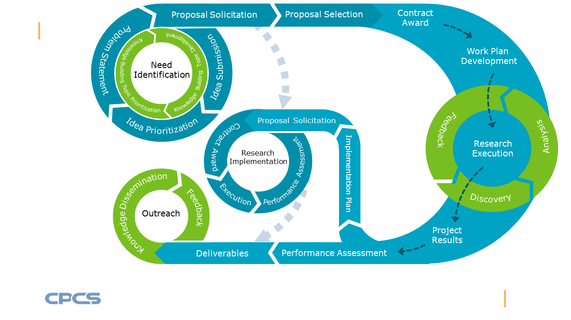

Figure 2 - Research Project Lifecycle

As shown in the above figure, the recurring process of research need identification enables LRRB to continuously identify and prioritize the research projects for funding. LRRB solicits research ideas directly from local transportation practitioners, who are most familiar with the research needs of their local systems.

Knowledge Building topic development and prioritization efforts led by the CTS, support LRRB’s need identification process by helping to identify the priority topics that reflect horizon thinking on long-term challenges and require innovative research to build knowledge. LRRB selects research ideas according to the Board’s established [criteria](#_Appendix_B._Knowledge), and the outreach consultant works with the selected idea authors to create need statements and releases them on [Ideascale website](http://www.dot.state.mn.us/research/need-statements.html).

The **Ideascale** website facilitates research and implementation idea solicitation for both LRRB and MnDOT.

Transportation practitioners in Minnesota can register on the website to submit a new idea or to vote on the ideas submitted by others to show support.

The MnDOT’s Office of Research & Innovation releases the ideas through the Request for Proposal (RFP) process and proposal solicitation. Then, LRRB reviews, selects, and then approves proposals, and makes funding allocation decisions. The MnDOT Office of Research & Innovation provides administrative and technical assistance during the funding allocation process. This office also supports project researchers in developing the work plan with the concurrence of the project’s TAP.

For the execution of the selected research projects, researchers from universities, MnDOT, and consulting firms (as subconsultants) conduct the research, while the LRRB and/or RIC monitors the progress. The research execution process has a circular flow as investigators address key research questions through data discovery and analysis. This analysis may provide insights and conclusions which can be improved by feedback from experts, especially those on the project TAP. While some threads of inquiry may result in dead ends or lessons learned (i.e., what not to do), most often additional opportunities are created for further research either in the same or new projects.

The final results of research are reported and disseminated by the LRRB’s Outreach Committee. Completed research projects may advance to research implementation if they meet certain criteria. The impact of research multiplies as local practitioners see potential applications through the technology transfer efforts of LRRB, through the various implementation tools and techniques employed by the RIC.

Finally, LRRB presents updates and communicates the results of research and implementation to local practitioners through the Outreach Committee efforts to close the feedback loop.

Research development and implementation milestones:

* Completion of Research idea submission: May – June
* Synthesis of new ideas: June – Dec
* Idea prioritization: Dec – March
* Need Statement Development: March – April
* Final need statement prioritization: June
* Implementation – consultant selection: June
* Implementation – scope, schedule, budget development: July – Sept
* Research RFP issued: August
* Research Proposal Solicitation: Aug – September
* Research Proposal review and selected for presentation (including Knowledge Building proposals): Oct
* RIC receives scope, schedule and costs from Consultants: Oct
* RIC awards work based on budget received from LRRB decision: March – Oct
* RIC forwards any unfunded proposals to LRRB: Dec
* Final Proposal selection: Dec
* Contracts execution: Dec – July
* Submission of implementation ideas from completed projects to RIC: March

The following subsections provide more details on the lifecycle of research sponsored by the LRRB. LRRB follows a fiscal year calendar with key milestones for different processes, as explained below.

### Needs Identification

The research needs identification process plays a critical role in developing an effective research program. The first and foremost step to initiating a research project and moving forward to developing the overall research investigation is identifying priority research topics. This step directly impacts the program's success, as well as the potential for research project implementation. LRRB recognizes the need for and seeks to fund both basic research (knowledge building) and applied research (problem-solving).

LRRB’s research projects investigate the methodologies, techniques, and strategies that lead to taking action against specific problems. Research projects typically include the following steps:

1. Understanding the need and its symptoms,
2. Investigating the causes and origins of the need,
3. Generating ideas and scenarios to solve the need,
4. Exploring and/or testing the ideas and solutions,
5. Assessing the results and knowledge gained,
6. Recommending viable solutions,
7. Creating a plan of action.

Involving the transportation practitioner is fundamental to the process of need identification. Local transportation practitioners, as well as MnDOT staff, city and county engineers, and university researchers help LRRB ensure selection of the right research topics and implement the research results through research idea submission.

Knowledge building topics encompass complex, emerging issues and require horizon-focused investigations, that are likely to be exploratory in nature, involve multiple disciplines, build the knowledge base for local practitioners, and illuminate the pathway toward effective solutions. These complex, emerging issues may require a series of incremental studies.

The Knowledge Building Priorities process engages the LRRB members in identifying long-term, complex challenges that can benefit from research. UMN CTS leads the [Knowledge-Building Priorities](#_Knowledge_Building_Priorities) effort, in partnership with LRRB and MnDOT Office of Research and Innovation. LRRB will consider innovative research proposals in response to Knowledge Building Priorities from University of Minnesota faculty and research staff. Knowledge Building Priorities are updated every 4 years. The process for updating Knowledge Building Priorities is described in Appendix B. The list of current KB topics is also provided in Appendix B.

LRRB accepts research and implementation ideas through the following methods:

The state aid road system was developed by the Minnesota State Legislature in 1957 to provide vital, high-quality connections necessary for the overall state highway network to function well. The [state aid rules](https://www.dot.state.mn.us/stateaid/programlibrary/stateaidrules.pdf) provide counties and cities with minimum standards for roads and bridges on the state aid system.

LRRB representatives hold sessions at 16 State Aid prescreening meetings during a fiscal year cycle, where city and county engineers can discuss their research and technology transfer needs, and learn about LRRB knowledge, tools and resources.

* Sharing ideas during the annual cycle of State Aid pre-screening meetings,
* Submitting ideas on the [Ideascale website](https://mndot-lrrb.ideascale.com/),
* Contacting an [LRRB board member](https://lrrb.org/board-members/) and sharing ideas directly.

After collecting and documenting the submitted ideas, LRRB synthesizes and combines similar ideas and then runs a research query to identify completed or ongoing LRRB projects that may address some of the ideas.

In the next step, LRRB sends a link to the city and county engineers to collect online votes. Each city or county engineer has 20 votes to spend on different ideas. The resulting ranked ideas are then presented at the LRRB’s March meeting at which the board discusses the ideas and sorts them into research, implementation, and synthesis and outreach categories. During the same meeting, the board reviews a prioritized list of implementation ideas submitted by the RIC. These ideas are selected from the previous year’s completed research projects. The board takes all of these ideas and selects the ones that will move to the needs statement development process.

Finally, LRRB selects and prioritizes the ideas that will advance through the needs statement development process (roughly 25 ideas are selected at the end of review process), and the outreach contractor proceeds to develop the research [Need Statements](https://lrrb.org/media/news-events/MnDOT-LRRB-Need-Statement-Form.docx). The need statements can be viewed online at the [MnDOT’s Office of Research &](http://www.dot.state.mn.us/research/rfp.html) Innovation web page.

LRRB announces the research project RFPs in the fall of each year, to solicit proposals from researchers and academic institutions. Researchers interested in submitting proposals are encouraged to work with the project champion listed for each particular research need statement during the development of the research proposal.

### Proposals

#### **Proposal Submission Process**

Proposals must be developed around Minnesota’s high-priority research (or implementation) needs and submitted during the proposal solicitation window (August to September). Proponents should use the standard [Proposal Form](http://www.dot.state.mn.us/research/process-and-docs/RFP%20Proposal%20Template.doc) provide on the MnDOT Office of Research & Innovation Website. Knowledge Building (KB) proposals are also accepted prior to the October LRRB meeting annually. Both RFP and KB proposals are then reviewed and considered for presentation at the December LRRB meetings. Researchers are encouraged to review the examples of previous research efforts on the [MnDOT’s Office of Research &](http://www.dot.state.mn.us/research/index.html) Innovation and [LRRB](https://lrrb.org/research/) websites.

By early December of each year, the researchers who have submitted proposals will be notified if a presentation is requested by the LRRB. Each presentation provides a high-level summary rather than a detailed description of the proposal. Overall, the proposal presentation should provide answer for the following questions:

* How are the expected benefits to be quantified?
* What steps required of the Cities and Counties to achieve full use of the research results?

Answers to these questions showcase the value of the research to the State of Minnesota and the transportation community and help the LRRB in final funding decision-making.

The LRRB accepts **off-cycle proposals** that meet certain criteria but the proposal must be **sponsored by a public sector champion**, such as a city or county engineer, MnDOT office director or the districts in order to receive funding. The project champion should be willing to participate on the TAP and state their consent for sponsoring the project in a letter or e-mail of support.

### Research Project Selection

In Late December of each year, LRRB awards funding to selected research projects.

As a result of discussions and member voting during the proposal screening meeting (in October), the Board publishes the short list of proposals for which the Board would like to hear investigator proposal presentations. Later, in an early December meeting, the LRRB reviews and selects the proposals for funding, using [Multiple Proposal Review Criteria](http://www.dot.state.mn.us/research/process-and-docs/Multiple-Proposal-Review-Form.docx). The criteria used for scoring the proposals are as follows:

* Addressing the problem and aligning with the need statement,
* Qualifications of the proposed research team,
* Expected benefits of research and implementation opportunities,
* Proposed research methodology,
* Proposed tasks, deliverables, and project schedule, and
* Alignment of the proposed costs with the value obtained from the final deliverables.

### Work Plans and Contracts

All projects funded by the LRRB must have a work plan before contract funds can be expended.

The project's Principal Investigator (PI) is responsible for the development of the project work plan. The PI also identifies who will write the final report.

The Office of Research and Innovation staff keeps a copy of the work plan and reports to the LRRB on work plan development status. Office of Research and Innovation will also assign the Project Advisor (PA) for the project and work with LRRB members to identify and assign the p who will approve and accept contractual deliverables.

### Project Technical Advisory Panel

Once a proposal is selected for funding, a Technical Advisory Panel (TAP) is established for the project to provide technical assistance and to monitor the administration of the contract. The process by which research is conducted for MnDOT and the Local Road Research Board encourages open dialog between the members of the TAP. This allows for a free exchange of ideas between the TAP members and is an important factor in creating research results that can be successfully implemented.

### Research Project Execution

For the execution of the selected research projects, the researchers from universities, MnDOT, and consultant subcontractors conduct the research, while the LRRB monitors the progress and the project’s TAP provides technical assistance to the researchers.

### Reports and Deliverables

During a research project, each task has a deliverable that must be approved by the project TL before payment can be made for the task. A final report must be completed for all projects funded by the LRRB. The [details](http://www.dot.state.mn.us/research/finalreport.html) and the length of the report vary depending on the type of project. The final results of the research projects are disseminated by the LRRB’s Outreach Committee.

The research sponsored by LRRB helps to improve the quality of Minnesota’s transportation systems. Therefore, completed research projects may advance for research implementation if they meet certain criteria, as discussed in the [Research Implementation](#_Research_Project_Implementation) chapter of this guide.

### Performance Assessment

Transportation research agencies garner resources by articulating the value of their research to stakeholders. Performance assessment is a vital link in this process as it helps agencies develop the case for the ways in which research matters, and to deliver a narrative highlighting the outcomes of research. Performance assessment accordingly reflects the lifecycle of research and related activities, and helps make the following arguments:

1. **Resource Tradeoffs** – LRRB puts limited resources to good use: assessing the value and outcomes of research to understand the trade-offs between the benefits of research and the resources required.
2. **Execution Capability** – LRRB attracts expertise and knowledge: assessing the value of the research sponsored by LRRB to make a case for why specialist researchers should continue to develop their capabilities and offer them to LRRB, and why volunteer specialists should continue to participate.
3. **Organizational Effectiveness** – LRRB is best placed to pursue local road research: documenting and communicating how LRRB effectively channels public sector resources into local road research.

By necessity, performance assessment is a continuous effort to support the value articulation process, i.e., developing the case for continued meaningful research and impact. However, assessment exercises are most closely tied to two major milestones. The first milestone for evaluation occurs during the research proposal process, which involves an assessment of a project’s expected benefits. The second milestone for evaluation arises after completion of the research project to determine if the project accomplished its goals and if results can be implemented, i.e., whether the expected benefits can be realized or captured.

To support the above, LRRB has acted on recommendations of the Strategic Plan to systematically monitor and assess the performance of its research activities:

* Research Feasibility Assessment: LRRB uses a simple framework, associated performance measures, and guidance for evaluating research project feasibility and importance at the project selection stage,
* Research Project Tracking: MnDOT Research Services has a well-developed database system – Automated Research Tracking System (ARTS) for tracking project attributes and progress. The system has been expanded to incorporate more information for performance assessment,
* Communication and Outreach for Performance Assessment: LRRB maintains a program-level research performance scorecard to close the feedback loop with project selection, corresponding funding allocation, and related outreach to practitioners.

### Implementation

After completion and evaluation of research projects, a final report is published and, when applies, an implementation plan is developed by the TAP. The LRRB uses the RIC to facilitate the implementation of research findings through various methods (i.e., LTAP/CTAP program, training courses, manuals, etc.) See the [Research Implementation](#_Implementation_Process) process for more details.

## Research Project Implementation

Research project implementation can be described as a systematic process in which the producers of enhanced knowledge (researchers, sponsoring agencies such as LRRB, DOTs, etc.) engage a certain audience (practitioners and stakeholders) with the purpose of transferring that knowledge.

The LRRB program includes a broad range of activities that surpasses any narrow definition of implementation. The core idea of implementation is directly encoded into LRRB’s mission: acquisition of and application of new knowledge. Almost all of LRRB’s activities follow from this and can be linked to practice.

### Implementation Project Selection Process

MnDOT Office of Research & Innovation collects implementation ideas from completed (or near completion) research projects. The implementation ideas are either submitted by the projects’ TAPs after investigating the potentials for implementation or through direct solicitation of ideas from the county and city engineers through the discussions facilitated at the pre-screening board meeting.

The Office of Research & Innovation facilitates the submission of implementation requests from completed or ongoing research projects. The list of implementation ideas is then added to the ideas solicited from the city and county engineers during the pre-screening board meeting.

In a March meeting each year, RIC prioritizes the list of implementation ideas collected from project TAPs. This prioritized list is then shared with LRRB to be compared with the prioritized implementations ideas solicited from city and county engineers. The board then selects the highest ranked ideas, and implementation needs statements are developed by the outreach consultant.

The needs statements are then reviewed and further prioritized by both LRRB and RIC prior to the LRRB’s summer meeting. During the summer meeting, LRRB develops a final list of implementation needs statements based on the voting results and then works with RIC to review the needs statements for completeness, funding options, and identification of project champions.

In the next step, RIC assigns the resulting implementation projects to consultants. RIC assigns the majority (about two thirds) of the implementation budget to the primary consultant. The remaining budget is typically assigned to the consultant directly selected from the TRAP list. This process increases efficiency by ensuring that implementation projects are undertaken by a dedicated team and eliminates the need for separately contracting the implementation projects.

The RIC primary consultant is under contract for a period of 3 years with an option to extend for an additional 2 years. After contract expiration, new RIC consultants are selected through a Request For Proposal (RFP) process. The RFP includes a list of implementation projects selected for the first year of the contract. After proposal solicitation and consultant selection, the year 2 and year 3 implementation projects will be identified through the process described above.

The Office of Research and Innovation staff develop the implementation contracts based on the objectives and goals solicited in the RFP and obtain the necessary approvals and signatures to enter into agreements with consultants on behalf of the RIC. Finally, the Office of Research and Innovation works with local transportation practitioners – the intended direct beneficiaries of LRRB’s new knowledge - to determine the impact of research and / or implementation.

LRRB Allocates RIC’s budget based on the volume and distribution of the prioritized ideas resulting from the LRRB’s March meeting, as well as the previous year’s implementation trends and continuation of implementation.

A step-by-step guide for RIC’s research implementation is provided on the [LRRB’s website](https://lrrb.org/media/members/12--RIC_Project_Selection_Process.pdf).

### Implementation Roles and Responsibilities

The implementation process can involve many participants: the LRRB, MnDOT, researchers, and other transportation practitioners. The summaries below highlight the expectations for RIC members and their responsibilities, implementation project TAP member responsibilities, as well as those of the contractors and transportation practitioners who collaborate with the RIC on projects. The RIC chair may invite other MnDOT staff to participate in project implementation.

1. The RIC’s duties include:

* Recommending tasks to receive funding,
* Selecting contractors to complete projects and managing implementation projects,
* Managing implementation budget (which LRRB determines with input from the RIC),
* Determining the need for a RIC TAP and selecting RIC members to chair it,
* Mitigating disputes and executing change of orders when necessary,
* Identifying RIC members and other professionals to serve on TAPs as technical experts,
* Working with the contractor and TAP to ensure the final product meets the needs,
* Determining final task product format and distribution,
* Reviewing and approving final task deliverables,
* Recommending information transfer methods to the Outreach Committee to introduce recently completed projects, products, and findings to local agencies and MnDOT.

1. TAP Duties include:

* Providing technical expertise and user perspective on projects,
* Reviewing task work plans and deliverables,
* Reviewing and recommending approval of final deliverables,
* Identifying the deliverables that need RIC’s action and bringing them for incorporation into RIC work effort,
* Serving as the chair or a TAP member of RIC projects.

1. MnDOT implementation duties include:

* Helping the LRRB and the RIC manage and administer contracts,
* Distributing completed products, and soliciting tasks for research and implementation,
* Serving as liaisons on the LRRB and RIC projects to help monitor progress and coordinate MnDOT involvement.

1. Primary Contractors implementation duties include:

* Works with the chair to set the agenda and support meeting logistics,
* Record and distribute meeting minutes,
* Solicit TAP members,
* Document changes which affect the initial objective of the project,
* Notify the Office of Research and Innovation of any matters which may affect contractual obligations.

### Implementation Tools

The RIC looks broadly at technology transfer opportunities, for ways to convey new techniques and knowledge to transportation practitioners. Most of these opportunities require a mix of implementation tools to support their success. The LRRB, RIC, and MnDOT’s Office of Research and Innovation offer assistance in determining the appropriate tools to transfer information for project implementation.

The following list outlines potential technology transfer tools available to MnDOT and the RIC for implementation:

* **Guidebooks** can take a variety of forms, including full reports, executive summaries, field manuals, or training guides. MnDOT Guidebooks also provide support for software development and distribution, report publishing, and electronic dissemination,
* **Spreadsheet Tools and Software** provide timely specialized expertise in a variety of road engineering topics to help practitioners improve performance and cost-effectiveness,
* **Instructional Videos** are used to provide training in the most effective and current methods in a variety of topics,
* **Powerpoint Presentations** are another way of providing training material and communicating research results,
* **Training Curriculums** of MnDOT’s Office of Materials and Road Research provide tools for practicing and technical training of its transportation partners,
* **Other Online Resources** are web pages and documents on the internet that provide information or data sources on different topics.

### Implementation Partnerships

The LRRB and RIC work with a variety of partnerships to promote the latest in research and implementation. The following list outlines LRRB’s partnership programs that are additional avenues for research implementation:

[Minnesota Local Technical Assistance Program (LTAP)](http://www.mnltap.umn.edu/about/staff/) is administered by the Center for Transportation Studies (CTS) at the University of Minnesota. The LTAP program offers several technology transfer vehicles aimed at local government engineering personnel. These include The LTAP Exchange, a quarterly newsletter targeted at transportation practitioners, training workshops, best practices manuals, conference and library reference support.

[Circuit Training and Assistance Program (CTAP)](http://www.mnltap.umn.edu/training/ctap/) is the result of MnDOT coordinating with the University of Minnesota's CTS and the LTAP to provide practical training to district offices, cities, counties and townships in all areas of maintenance. CTAP uses a fully equipped van to provide on-site training across the state of Minnesota. The workshops are often hands-on with demonstrations of new equipment, materials, and technologies.

[Operational Research Assistance Program for Local Transportation Groups (OPERA)](https://lrrb.org/operational-research-program-for-local-transportation-groups-opera/) Fund is set out to support and assist any innovations relating to field maintenance operations. This fund also promotes facilitation and dissemination of maintenance operations technology through the Circuit Training and Assistance Program (CTAP).

[MnDOT State Aid](https://www.dot.state.mn.us/stateaid/scene.html) promotes new LRRB products by email list-serve and through the E-Scene Newsletter.

[MnDOT Office of Research & Innovation](http://www.dot.state.mn.us/research/) shares LRRB news and information via its website, blog, newsletter, and social media sites.

[MnDOT Communications](https://www.dot.state.mn.us/information/orgchart/co/communications.pdf) publishes several internal and external publications and works with media on potential news and feature stories.

[MnDOT Library/Information Services](https://www.dot.state.mn.us/library/mtl.html) assists with information searches, including articles, publications, and research reports. MnDOT library also loans material related to Professional Engineering (PE) exam to the city and county engineers.

[MnDOT’s Office of Materials and Road Research](http://www.dot.state.mn.us/materials/) is a research laboratory that can assist in physical testing and field-testing. The laboratory also conducts training for some implementation initiatives, writes technical papers, and maintains a web site.

### Evaluation

The considerable time, effort, and resources invested in producing enhanced knowledge translate into positive impact on the transportation system only when those who can apply this knowledge have absorbed and integrated it. Evaluation of implementation efforts is important for assessing the overall impacts ofimplementation, and also of the originating research when applicable, to close the feedback loop for research and implementation decision-making.

Implementation can often be an iterative process; projects evolve over time and must be adapted to available resources, and sometimes new findings in related research. Given the evolution, and also the long time that it takes to observe the impact of implementation, LRRB and RIC have adapted its implementation performance assessment approach to make the best use of limited resources.

RIC first identifies (while making the decision to fund implementation) a subset of implementation projects that can be tracked over a time-frame of 3-5 years during and after implementation has commenced to assess and report on performance. RIC also establishes the relevant performance measures for each implementation project based on project scale, user characteristics, and practical assessment methods.

To support the above, LRRB and RIC have acted on recommendations of the Strategic Plan to systematically monitor and assess the performance of its implementation program:

* Implementation Feasibility Assessment: LRRB uses a simple framework, associated performance measures, and guidance for evaluating implementation project feasibility and importance at the project selection stage.
* Implementation Project Tracking: MnDOT’s Office of Research & Innovation has a well-developed database system – Automated Research Tracking System (ARTS) for tracking project attributes and progress. The system has been expanded to incorporate more information for performance assessment, including tracking projects for a longer horizon of three to five years of post-implementation.
* Communication and Outreach for Performance Assessment: LRRB maintains a program-level implementation performance scorecard to close the feedback loop with project selection, corresponding funding allocation, and related outreach to practitioners.

## Research Resources

### Research Project Expertise

Other than the Principal Investigator who is the researcher responsible for the execution of the project, each research project of the LRRB is supported by the TAP, which provides technical guidance and quality assurance. Each member of the TAP has a particular role to play that is essential to the success of the research project. LRRB may also ask the practitioners(s) who submitted the selected ideas to serve on the project TAP, to provide guidance for the researchers who conduct the project and ensure that the project meets the needs of the local transportation system.

### Research Support

#### **Minnesota Transportation Libraries**

Established in 1995, Minnesota Transportation Libraries is a collaborative effort of the LRRB, University of Minnesota Center for Transportation Studies (CTS), and MnDOT. LRRB helps fund the Minnesota Transportation Libraries to make transportation-related information provided through the MnDOT Library, the CTS Library, and other Knowledge Networks more readily accessible.

The two libraries work together to offer library and information services to the state's transportation community. These services include literature searches on transportation topics and assistance with reference and research questions. With access to an international catalog of resources, library staff can identify, locate, and borrow transportation-related information materials from libraries around the world for local use. Library staff catalog LRRB and other project reports, videos, and other materials and add this information to this same international catalog. As a result, Minnesota's research products can be identified by researchers and practitioners around the globe.

Services and benefits provided by the Minnesota Transportation Libraries to local agencies include:

* Providing the highest priority in library services to the city and county officials, along with MnDOT staff,
* Communicating monthly to over 500 city and county officials informing them of newly received library materials, and annual reminders of the availability of library services to them,
* Answering reference and research questions including literature searches on transportation topics,
* Purchasing and lending materials of particular interest to local officials,
* Cataloging LRRB-funded research reports, and announce them to transportation libraries around the world, making these resources known and available worldwide,
* Obtaining books, articles, and other materials that the library does not own through interlibrary borrowing agreements with library partners,
* Filling requests for LRRB reports, videos, and Powerpoint presentations, and troubleshooting any related questions or problems,
* Providing a welcoming physical space, including computer and Wi-Fi access for city and county officials who come to the Transportation Building or the Capitol area,
* Loaning required study resources and practice material for the PE exam,
* Making over 400 journal titles available to fill requests,
* Maintaining online subscriptions, transportation databases, newspaper articles, and online journals to fill customer requests,
* Providing full library services to consultants working on LRRB-funded research,
* Marketing library services by including a link on the LRRB, City Engineers Association of Minnesota (CEAM), Minnesota County Engineer Association (MCEA), and Multicultural Center for Academic Excellence (MCAE) websites.

#### **Minnesota's Cold Weather Pavement Testing Facility - MnROAD**

MnROAD is a pavement test track made up of various research materials and pavements owned and operated by the Minnesota Department of Transportation and supported by LRRB’s funding contributions. Located near Albertville, Minnesota, MnROAD works in conjunction with MnDOT's [Materials and Road Research Lab](http://www.dot.state.mn.us/materials/) to find ways to make roads last longer, perform better, cost less to build and maintain, be built faster and have minimal impact on the environment.

NRRA consists of members from:

* Transportation agency who participates in decision making about MnROAD construction and research objectives, determine budgets and timelines, and select and participate in project teams,
* Associate members who provide expertise throughout the research process.

NRRA members join the alliance through annual payment of fees.

#### **National Road Research Alliance (NRRA)**

NRRA is a dynamic partnership among state DOTs, private companies, academic institutions, and associations to improve the future sustainability of our roads through research and a commitment to cooperative implementation.

The alliance sponsors research at the MnROAD test track and makes the decisions for MnROAD construction and research. LRRB is a member of the NRRA through its funding contributions to MnROAD.

NRRA’s mission is to help agencies nationwide achieve similar benefits from real-world road research and to provide industry and academia a facility for evaluating cutting-edge pavement technologies.

#### **Local Technical Assistance Program (LTAP)**

A collaborative effort by the LRRB, the Federal Highway Administration (FHWA), MnDOT, and the University of Minnesota's CTS, the Local Technical Assistance Program (LTAP) provides support and direction for a variety of transportation implementation activities. The LTAP is composed of a national network of centers – one in every state, Puerto Rico, and a regional center serving tribal governments. The LTAP national network maintains important links to national research implementation and technology transfer efforts.

The Minnesota LTAP improves the skills and knowledge of local transportation agencies through training, technical assistance, and technology transfer. The LTAP mission is to foster a safe, efficient, environmentally sound transportation system by improving skills and knowledge of local transportation providers through training, technical assistance, and technology transfer.

Under the LTAP Program, FHWA offers each center base funding with the requirement of each to secure matching funds at the local/state level. The LRRB matches federal funding for the Minnesota LTAP Program to support its base program services, including the delivery of ongoing and subsidized training workshops, quarterly publications of the Technology Exchange newsletter, maintenance of a customer database, library lending and reference services, and information and technical assistance referral.

In addition to matching base program funds, the LRRB uses “continuing program funds” to annually support continued, in-demand LTAP services that extend beyond the base services. These continuing activities include:

1. Circuit Trainer Assistance Program (CTAP):

This program provides training in the latest transportation-related tools and technologies to maintenance personnel from townships, cities, counties, and the state. It uses a fully equipped van to provide on-site technical assistance and training throughout Minnesota—at or near your place of work. Participants receive down-to-earth, practical training, and hands-on demonstrations of new equipment, materials, and techniques. The classes also give workers an opportunity to share their own maintenance ideas and innovations with peers.

1. Maintenance Research Expos:

*Minnesota Fall Maintenance Expo (2-day)*: This two-day event complements the Minnesota Roadway Maintenance Training and Demo Day and primarily addresses fall and winter transportation maintenance issues. Vendors and speakers present a variety of new equipment and information through an extensive indoor and outdoor display area. The annual snowplow "roadeo" allows individuals and pairs of competitors to compete on a closed course.

*Minnesota Roadway Maintenance Training and Demo Day (1-day):* This one-day event focuses exclusively on education and technology exchange through classroom sessions and outdoor demonstrations. Attendees learn about the latest practices, innovations, and research related to Minnesota’s roadway maintenance operations.

1. Workforce Development Activities:

Minnesota LTAP's goal, on behalf of the LRRB, is to continue reaching out to as many current students and new graduates as possible--and connecting them with multiple employers and professional organizations. Career development includes activities such as continued support of internship programs, connecting students and employers through transportation-related career fairs and/or other on-campus activities, and career development opportunities for engineering and planning students.

#### **Operational Research Assistance (OPERA) Program**

The Minnesota Local Road Research Board’s Local Operational Research Assistance (OPERA) Program helps to develop innovations in the construction and maintenance operations of local government transportation organizations and share those ideas statewide. OPERA encourages maintenance employees from all cities and counties to get involved in operational or “hands-on” research. LRRB funds OPERA program and its administration. The OPERA program then provides funding of up to $20,000 for eligible projects through an annual request-for-proposal process.

## Meetings, Workshops, and Reports

The LRRB and RIC members have multiple meetings annually. Members frequently meet to prioritize research and implementation ideas, review proposals, approve the expenditure of LRRB funds, and to make policy decisions.

LRRB and RIC meetings enable the members to engage in discussions with researchers and project investigators. Such discussions help the members to learn more about the state of research in various topic areas and flesh out some specific research problems related to each specific topic. The dialogue also helps researchers develop stronger, more focused Knowledge Building research proposals in response to the annual RFP. Dates, agenda, and minutes of all the LRRB and RIC meetings are available on the LRRB web page.

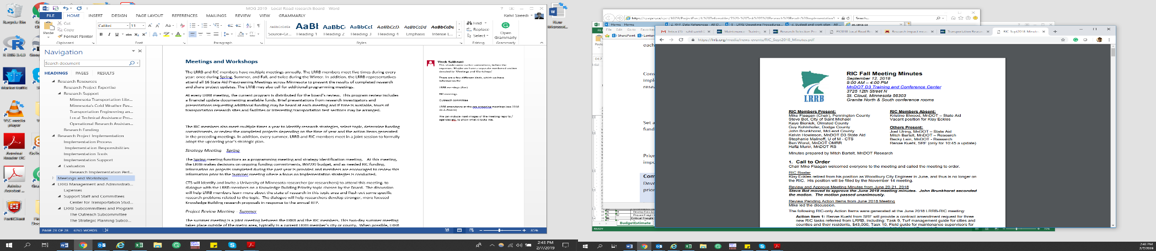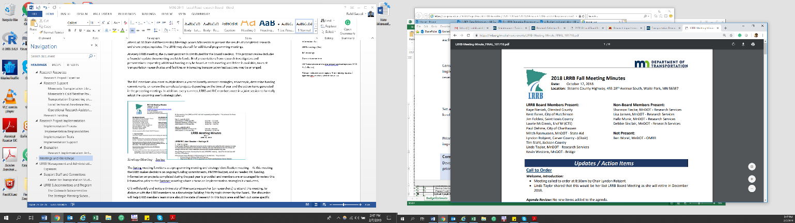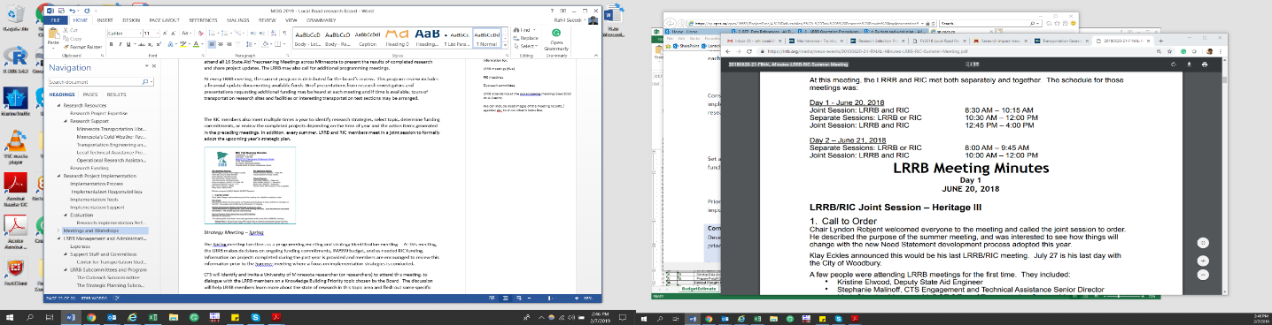

Figure 3 Sample LRRB and RIC Meeting Minutes

### LRRB Meetings

**Spring/March Meetings:** Reviewing ideas, setting budgets, and establishing priorities.

**Summer/June Meetings:** Needs Prioritization.

**Fall/October Meetings:** Program Refinements.

**Winter/December Meetings:** Final evaluation and selection of funded projects.

**May and October State Aid Prescreening Meetings:** Some LRRb memebrs participate in these meetings but mainly a function of the outreach committee for idea consideration for funding as a research or technology transfer project.

LRRB convenes four internal meetings a year to address Board business, as part of its annual cycle of activities: once during Spring, Summer, Fall, and Winter. At every LRRB meeting, the current program is distributed for review. This program review includes a financial update documenting available funds. Brief presentations from research investigators and presentations requesting additional funding may be heard at each meeting, and if time is available, tours of transportation research sites and facilities or interesting transportation test sections may be arranged.

LRRB representatives – primarily members of the Outreach Committee and/or the Outreach consultant - attend all 16 State Aid Prescreening Meetings across Minnesota. In these external meetings, LRRB presents the results of completed research and shares updates and accomplishments in flagship projects. LRRB also maintains a continuous feedback loop with local transportation practitioners through its participation in meetings convened by partners. LRRB and RIC members meet in a joint session to formally adopt the upcoming year’s strategic plan.

Occasionally email is used to gain concurrence if an issue arises between scheduled meetings.

#### **LRRB TAP Meetings**

TAPs usually meet to discuss progress, when tasks are due, and to review deliverables. The following outlines TAP meeting content and responsibilities:

**Introductory meeting:** Led by the TAP chair, this meeting focuses on the following issues:

* Outlining the research process,
* Reviewing the roles and responsibilities of TAP members,
  + Suggestions by members of relevant resources,
  + Review of target audiences and proposed deliverables,
  + Review of the project budget,
  + Schedule for the next TAP meetings,
  + Assignment of tasks to TAP members, as necessary.

**Follow up meeting(s):**

* Project update by the project’s PI,
* Discussion of project status, accomplishments, and activities,
* Review of budget expenditures to date and schedule,
* Discussion of questions or outstanding issues,
* Identification of action items and assigned tasks,
* Review and/or approval of any deliverables.

**Final meeting:**

* Project update by the project’s PI,
* Discussion of project status, accomplishments, and activities,
* Review and approval of final deliverable,
* Discussion of dissemination strategies and next steps,
* Review of outstanding issues,
* Determination of next steps, if necessary, and assignment of tasks.

In some situations, it may be beneficial for the TAP to meet more frequently, such as quarterly or monthly, as appropriate based upon the project scope.

### RIC Meetings

**Spring/March Meetings:** Review the implementation project ideas.

**Summer/June Meetings:** Consult with LRRB on needs prioritization and assignments.

**Fall/September Meetings:** Program refinement.

**Winter/November Meetings:** Optional meeting based on needs.

The RIC members also meet multiple times a year to discuss research implementation ideas list, review funding budget and determine commitments, or review marketing products for the completed projects depending on the time of year and the action items generated in the preceding meetings.

As part of every RIC meeting, the LRRB/RIC liaison member updates the other members and the chair about the discussions and decisions occurred during the most recent LRRB meeting. RIC members may transfer their issues or requests regarding the LRRB decisions and processes through the liaison member.

#### **RIC Project TAP Meetings**

Each implementation project has a contractor who schedules the RIC TAP meetings and develops the meeting agendas with the help of RIC TAP chair. The following outlines TAP meeting content and responsibilities:

**Introductory meeting:** Led by the RIC TAP chair, this meeting focuses on the following issues:

* + Problem statement, objectives, and potential benefits,
  + Suggestions by members of relevant resources,
  + Identification of key project issues,
  + Review of target audiences and proposed deliverables,
  + Review budget,
  + Schedule for the next TAP meetings,
  + Assignment of tasks to TAP members, as necessary.

**Follow up meeting(s):**

* Project update by contractor,
* Discussion of project status, accomplishments, and activities,
* Review of budget expenditures to date and schedule,
* Discussion of implementation questions,
* Review outstanding issues,
* Identify action items and assign tasks,
* Review and/or approve any deliverables.

**Final meeting:**

* Project update by contractor,
* Discussion of project status, accomplishments, and activities,
* Review and approval of final deliverable,
* Discussion of dissemination strategies and next steps,
* Review of outstanding issues,
* Determination of next steps, if necessary, and assignment of tasks.

The RIC TAP may wish to schedule additional meetings or make additional recommendations to the RIC or the LRRB regarding a project. The Office of Research and Innovation representative also tracks the progress of the tasks in a database. All final deliverables are subject to review and approval by the full RIC.

### Annual “LRRB At-A-Glance” Reports

Each year, MnDOT’s Office of Research and Innovation prepares an annual report on behalf of LRRB for submission to the Commissioner of Transportation. The report includes a table that lists the active and completed LRRB-funded projects for that fiscal year and technical summaries of completed projects. The Office of Research and Innovation prepares the report, which reflects those projects funded at the previous programming meetings, to the Commissioner by February 1st. The LRRB Chair and the Commissioner of the Minnesota Department of Transportation sign the cover letter that accompanies the report. Beginning in 2020, the LRRB State-Aid representative will receive the authority to sign the cover letter in place of the Commissioner.

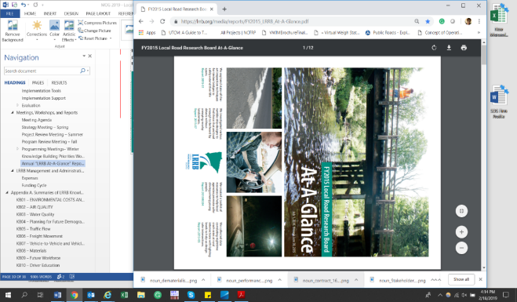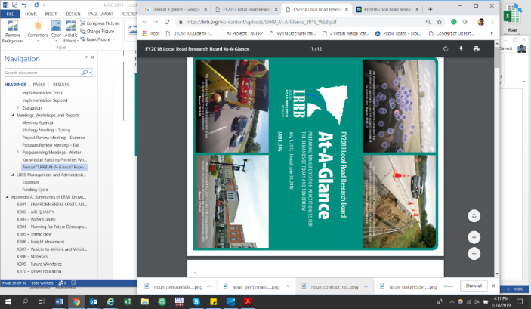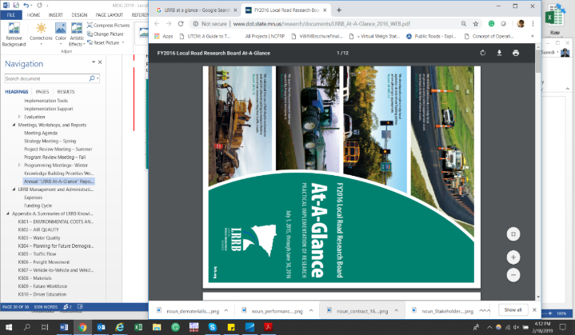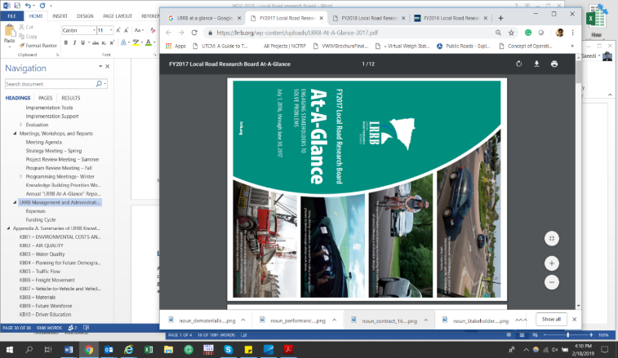

Figure 4 – Sample LRRB At-A-Glance Reports

The At-A-Glance reporting structure has served LRRB well as a summary report over the years. In recent years it has also played a dual role of marketing recent accomplishments, as well as announcing initiatives and meetings in “newsletter” fashion.

## LRRB Management and Administrative Activities

Administrative management is important in any organization or entity to ensure smooth operations, continuous communication, and optimum use of resources. LRRB’s administrative procedures support the Board in achieving its strategic goals.

The following sections provide a high-level description of LRRB’s budget for following its administrative processes, as well as the research project funding cycle and financial management.

### Administrative Budget

Investigation 999 serves as LRRB's administrative account. Expenditures from this account provide funding for administrative support, program development, and work not covered by a specific LRRB investigation. The following lists items funded under Investigation 999:

* LRRB and RIC meeting expenses.
* Conference travel and registration expenses for LRRB sponsor events, including lodging, transportation, food, and other miscellaneous expenses.
* Publication expenses for videos, DVDs, and other technology transfer products from LRRB research
* Consultant contract technical services for editorial review of published reports, development of transportation research synthesis and technology summaries, marketing products, maintenance and support of the website, and other activities related to the research program.
* Miscellaneous expenses to cover printing of materials and purchasing of program support items.

At the annual programming meeting (LRRB’s Spring/March meeting), the LRRB allocates funds to support the INV 999 initiatives for the upcoming year.

### Funding Cycle

Each year, the County Screening Board and the City Screening Committee recommend to the Commissioner of Transportation a sum of money that the Commissioner of Transportation shall set aside from the county state-aid highway fund and the municipal state-aid street fund. According to Minnesota statutes, the amount set aside from each of these funds shall not exceed 1/2 of one percent of the preceding year’s apportionment sum.

The LRRB’s funding cycle is based on the state calendar year (July 1st to June 30th). The LRRB annual budget has grown from about $86,000 in 1960 to a current budget of approximately $4.0 million.

### LRRB Rollover Money

Yearly funds set aside for the LRRB can be carried forward for one year. Any unobligated balance remaining in the research accounts at the end of each year from the sum set aside for the year immediately previous are transferred back to the county and municipal state aid highway funds. This means that LRRB has 2 years to spend each year’s apportionment sum. Therefore, it is necessary to review the “balance forward in” each year to make sure at least that amount is spent during the year. This way, no balance needs to be canceled as last year’s apportionment that was rolled over is spent.

### Financial Services

MnDOT’s Office of Research & Innovation has several mechanisms for monitoring the project and contracts. The Financial Services Section and the Research Management Section work collaboratively within the Office of Research & Innovation to anticipate and mitigate potential issues.

The Office of Research & Innovation has created the Automated Research Tracking System (ARTS) database to manage all tasks related to the administration of research including tracking proposals, project progress through tools such as system-generated alerts and project outcomes. ARTS allows life-cycle tracking of research projects to understand project performance and support decision-making. It has extensive reporting capabilities so that the data can be looked at from multiple aspects. Finally, this enables the eventual implementation of the research.

# Appendix A. Affiliated Programs and Collaborating Research Organizations

**CTS**

The Center for Transportation Studies was created in 1987 to serve as a resource and facilitator helping University faculty and research staff connect with practitioners and policymakers. They work to see that new knowledge improves transportation decisions, making a better and safer transportation system. CTS is an independent University Center reporting to the Vice President for Research. They sponsor many conferences, presentations, and opportunities to be involved. Their funding comes from a variety of sources including FHWA, USDOT, State Legislature, MnDOT, Met Council, and the LRRB. <http://www.cts.umn.edu>

**Guidestar**

Minnesota Guidestar is the State’s Intelligent Transportation Systems program. Its mission is to research, test, and deploy advanced transportation technology to save lives, time, and money. The Board of Directors includes MnDOT, FHWA, U of M, counties, cities, and numerous other private and public partners. The funding comes from both Trunk highway and federal funds. <http://www.dot.state.mn.us/guidestar/index.html>

**ITS MN**

The goal of the Intelligent Transportation Society Minnesota is to foster grassroots participation and partnerships focused on implementation results. It is a state chapter of ITS America. It is a voluntary, not for profit organization with yearly dues and an elected Board of Directors. [www.itsmn.org](http://www.itsmn.org)

**LTAP**

The Minnesota Local Technical Assistance Program is part of the National LTAP Association formed by the Federal Highway Administration (FHWA). Their mission is to improve the skills and knowledge of local transportation agencies. They are housed at the U of M within CTS. LRRB provides a match to the base funding provided by the FHWA. [www.mnltap.umn.edu](http://www.mnltap.umn.edu)

**MnDOT Materials Office**

They provide technical advice to research panels as well as to conduct some Materials research. They are funded by the Trunk Highway fund in the DOT budget. Office [www.mrr.dot.state.mn.us](http://www.mrr.dot.state.mn.us)

**MnROAD**

This is the pavement research facility on I-94 near Albertville exposed to live traffic loads and weather. It includes a low volume loop with both bituminous and concrete designs. Some cells were reconstructed in 2011, and more will be done in 2012. It is highly instrumented, and the data is available to researchers around the world. LRRB and MnDOT provide the operating funds. <http://www.dot.state.mn.us/mnroad>

**NATSRL**

The Northland Advanced Transportation Systems Research Laboratories located on the Duluth Campus of the University of Minnesota is a cooperative effort of the ITS Institute, CTS and UM staff. NATSRL researches comprehensive winter transportation systems and the transportation needs of cities in small urban areas. The funding comes from the ITS Institute. [www.d.umn.edu/natsrl](http://www.d.umn.edu/natsrl)

**NRRA**

The National Road Research Alliance is a national pooled fund that helps direct and compliments the use of the MnROAD test track for local, regional and national research, tech transfer, and implementation needs. As a local sponsor of the test track, the LRRB is a member of the NRRA. Other partners include the Minnesota, California, Illinois, Michigan, Missouri and Wisconsin Departments of Transportation, along with several industry associate members. [www.mndot.gov/mnroad/nrra](http://www.mndot.gov/mnroad/nrra)

**OPERA**

The Local Operational Research Assistance Program is a $70,000 per year program of the LRRB to promote hands-on operational research at local agencies. Projects are capped at $10,000, and the program is intended to encourage maintenance staff to propose hands-on research. [www.lrrb.org](http://www.lrrb.org) or [www.mnltap.umn.edu/About/Programs/OPERA](http://www.mnltap.umn.edu/About/Programs/OPERA)

**Roadway Safety Institute**

The new Roadway Safety Institute at the University of Minnesota focuses on researching issues related to traffic safety systems and high-risk road users. [www.roadwaysafety.umn.edu](https://sp.cpcs.ca/cpcs/16659/ProjectExec/4.%20Deliverables/08%20-%20LRRB%20Operating%20Procedures/www.roadwaysafety.umn.edu)

**SALT**

State Aid for Local Transportation: After research has been done and training and tools developed, SALT sponsors the continuing education or web presence of proven tools from the State Aid Administrative Account. www.dot.state.mn.us/stateaid

# Appendix B. Knowledge Building Priorities: Update Process and Current Topics

***Background***

Knowledge Building (KB) Priorities generate research that addresses emerging, complex issues to advance the state of knowledge on critical transportation topics. KB Priorities engage LRRB in identifying long-term challenges that can benefit from research.

CTS leads the KB Priorities effort, in partnership with LRRB and MnDOT. LRRB considers innovative research proposals in response to KB Priorities from University of Minnesota faculty and research staff.

KB Priorities are updated every 4 years. The process used to manage the update in 2019 is described below. Also outlined is the approach for monitoring KB Priorities and sharing researcher insights with LRRB in interim years. Finally, this appendix presents a summary of KB Priorities generated in 2019 for the 2019-2023 timeframe.

***2019 Update Process***

*February: CTS Reviews Process with LRBB Chair and MnDOT State Aid*

* Review process and schedule for updating KB Priorities.

*Late February/Early March: CTS Meets with MnDOT State Aid and SRF*

* Overview of what was learned from the screening board process that may inform KB Priorities discussion at March LRRB meeting.

*March: LRRB Meeting*

* Provide researcher insight on key transportation issues and gather initial information on KB Priorities from board members.

*Late-March to Early-April: Workshop Prep*

* Prepare for late-April workshop to review board members input and refine KB Priorities.

*Late-April: Workshop*

* Refine KB Priorities by gathering input on which priorities to remove, modify, or add.

*Mid-May: Review Draft KB Priorities*

* Distribute draft priorities to LRRB for review and comment.

*June: LRRB Meeting*

* Finalize KB Priorities in time for FY21 annual solicitation in August.

*Mid-July: Release Updated KB Priorities*

* Distribute updated KB Priorities in preparation for the annual solicitation process in August.

***Monitoring KB Priorities and Sharing Researcher Insights***

***Summary of 2019 Knowledge Building Priorities***

The following is the latest published list of KB Priorities. The list will be updated based on the forthcoming new list in July 2019.

Table 1 LRRB Knowledge Building Priorities.

|  |  |  |  |
| --- | --- | --- | --- |
| KB Priority | | | Description |
| C:\Users\rsaeedi\Downloads\noun_environmental_690092_000000.png | Environmental Costs and Benefits | KB01 | Development of a cost-benefit analysis method for environmental considerations and policies, including changes brought about by roadway usage, economic conditions, etc. |
| C:\Users\rsaeedi\Downloads\noun_car pollution_659078_000000.png | Air Quality | KB02 | Research focused on technology effectiveness and implementation for improving air quality. |
| C:\Users\rsaeedi\Downloads\noun_water pollution_592294_000000.png | Water Quality | KB03 | Investigating the capability of watershed to sustain future development, and effects of road infrastructure on local water quality, especially in regards to runoff and road-salts. |
| C:\Users\rsaeedi\Downloads\noun_people_1707997_000000.png | Planning for Future Demographics and Social Expectations | KB04 | Investigating the mobility, social trends, and equity between socio-economic groups with respect to traditional and modern transportation modes. |
| C:\Users\rsaeedi\Downloads\noun_Traffic_1668436_000000.png | Traffic Flow | KB05 | Focusing on technologies and incentives to improve traffic flow management while ensuring the consensus between agencies. |
| C:\Users\rsaeedi\Downloads\noun_manufacturer_2216637_000000.png | Freight Movement | KB06 | Incentivizing a cooperative, integrated, and intermodal freight network through the application of new technologies and development of a year-round 10-ton network or designated access roads to facilitate consistent freight traffic flow. |
| C:\Users\rsaeedi\Downloads\noun_Connected Car_2100191_000000.png | V2V and V2I Technologies | KB07 | Utilizing the potentials provided by vehicle-to-vehicle and vehicle-to-infrastructure technologies to reduce vehicle crashes that most often result from driver error. |
| C:\Users\rsaeedi\Downloads\noun_Highway_461595_000000.png | Materials | KB08 | Focusing on cost-effectiveness and environmental friendly material for use in roadway construction and maintenance. |
| C:\Users\rsaeedi\Downloads\noun_work force_1848916_000000.png | Future Workforce | KB09 | Changing the nature of the modern workforce in terms of employment, worker retention, training, and retirement. |
| C:\Users\rsaeedi\Downloads\noun_Driver_48705_000000.png | Driver Education | KB10 | Increasing effectiveness and incentives for driver education programs between demographics and application of new technologies. |
| C:\Users\rsaeedi\Downloads\noun_Favorite_2155166_000000.png | Design standards | KB11 | Designing new standards to accommodate new needs with limited resources and financial environment. |
| C:\Users\rsaeedi\Downloads\noun_Stakeholders_155566_000000.png | Public Engagement | KB12 | Development of public engagement standards and guidelines for practitioners, for equitable application in different social contexts. |
| C:\Users\rsaeedi\Downloads\noun_dematerialisation_2225052_000000.png | Innovative Contracting – Paperless Designs & Construction Plans | KB13 | Introduction of new technologies to improve the efficiency and reduce risks and issues of the construction documentation practices. |
| C:\Users\rsaeedi\Downloads\noun_performance_805827_000000.png | Innovative Contracting – Performance-Based Contracting | KB14 | Focusing on performance-based contracting methods and tools to reduce contracting risks and policy externalities. |

# Appendix C. CTS Research Councils

The Center for Transportation Studies (CTS) at the University of Minnesota reports to the Office of the Vice President for Research. This positioning allows CTS to take a comprehensive perspective and be a focal point for all things related to transportation research and education at the University of Minnesota. CTS works with Faculty and Research Scholars and affiliated researchers in more than 30 academic departments to carry out sponsored research projects.

**Four councils** support the Center's activities in transportation research, and a fifth council supports educational and engagement efforts.

The Council members meet a minimum of three times per year; fall and winter meetings are generally held in conjunction with research seminars.

CTS Research Councils provide a forum for transportation professionals and researchers to exchange information on current transportation issues and trends. They bring together University faculty and staff with practitioners from the public and private sectors to recommend a direction and participate in improving the Center's research, education, and engagement programs.

Activities of the four CTS Research Councils include providing advice during research project activities, identifying and advancing emerging research needs and opportunities, participating in seminars and other mechanisms to disseminate research results, and assisting in planning the annual CTS Transportation Research Conference.

Council members are appointed by the CTS director on behalf of the CTS Executive Committee, following nomination by the council chair. Approximately one-third of council members are University faculty or staff. Non-University members include a balance of business, government, and other interests.

A membership rotation occurs every three years. Though members may serve more than one consecutive three-year term, an effort is made to rotate approximately one-third of council membership during a rotation year. In addition to members, “friends” of councils also participate in council activities. New members will often be drawn from friends who are active within councils.

The [Environment and Energy in Transportation Council](http://www.cts.umn.edu/about/structure/councils/environment) examines topics such as air and water quality, stormwater management, erosion control, roadside vegetation, climate change, alternative fuels, greenhouse gas emissions, and more.

The [Transportation Planning and the Economy Council](http://www.cts.umn.edu/about/structure/councils/economy) examines topics concerning land use, urban design, community and human issues, transportation modes, funding and finance, economic development, freight and logistics, public policy, the global economy, and more.

The [Transportation Safety and Traffic Flow Council](http://www.cts.umn.edu/about/structure/councils/safety) examines intelligent transportation systems, traffic detection, traffic control, crash analysis, machine vision, traveler information systems, human factors, and injury prevention.

The [Transportation Infrastructure Council](http://www.cts.umn.edu/about/structure/councils/infrastructure) focuses primarily on pavement and bridge research. Topics include materials, pavement performance, bridge design and maintenance, innovative construction and contracting deicing and corrosion, and water impacts.

# Appendix D. LRRB and RIC Annual Research Program Development Process

The process diagram presented in the following page is intended to provide new and currently serving LRRB and RIC members with an efficient reference guide for understanding key inputs, outputs, and activities relative to the annual LRRB and RIC meeting cycle.

The diagram combines the LRRB and RIC meeting processes (middle vertical bar) and describes the inputs that inform each meeting, responsibilities (boxes on the left), and the resulting meeting outputs (boxes on the right). To distinguish the responsible parties, the diagram uses color coding as provided in the legend below the diagram.

LRRB process characteristics:

* Efficient annual process accomplished through four intensive 1‐2 day meetings.
* Clear, consistent meeting inputs and outcomes year to year.
* Considers a broad range of research ideas from transportation industry professionals from throughout the State of Minnesota.
* Ideas prioritized for funding according to program needs and budget limitations.
* Ideas screened from consideration in one year can be developed/refined for consideration in a future year.
* Relies on the guidance of dedicated city and county engineers serving as board members.
* Guides program priorities and outcomes.

RIC process characteristics:

* Efficient annual process accomplished through three to four intensive 1‐2 day meetings.
* Clear, consistent meeting inputs and outputs year to year.
* Considers a broad range of implementation ideas from completed research and input from transportation industry professional from throughout the State of Minnesota.
* Ideas prioritized for funding according to program needs and budget limitations.
* Ideas screened from consideration in one year can be developed/refined for consideration in a future year.
* Relies on the guidance of dedicated city and county engineers serving as board members.
* Manages implementation projects ensures valued outcomes in support of the LRRB program.
* Guides RIC implementation project outcomes with a focus on training tools such as manuals, ADA training, LTAP, and guidebooks.

